Guided Capstone Project Report"
Prince Zogli

Introduction and Purposes: Big Mountain wants to maximize its returns, relative to its position in the market. However, the resort does not have a strong sense of what facilities matter most to visitors, particularly which ones they are most likely to pay more for. As such data available to the resort was leveraged to build a predictive model for ticket price and in the end identify key variables that impact price development.

Rationale: To come up with a pricing model for Big Mountain ski resort tickets in our market segment.
Methods: Data was assessed for useability, leading to removing of missing data, miss labelled states and weak features.

Results:
Data wrangling and other processing techniques were utilized to decide on 7 variables as top predictors of price. These include: vertical_drop, Snow Making_ac, total_chairs, fastQuads, Runs, LongestRun_mi, trams and SkiableTerrain_ac.
Both linear model and neural network
Our modelled price is $93.69, relative to actual of $81.0. With a MSE of $10.17, there is room for at least a $10.00 increase.
Though closing 4 or 5 runs is feasible with no lose in revenue, closing up to 6 leads to a dramatic drop in price and thus revenue.
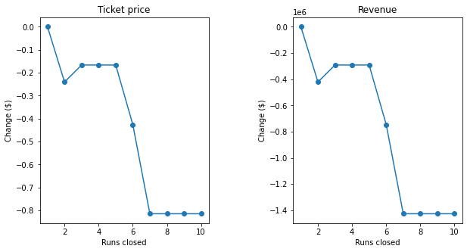
Figure 1: Impact of closing runs on price and revenue

While assessing scenarios, we found that increasing the vertical drop by 150 feet, and adding an additional run and chair lift, support’s increasing ticket price by $16.70. Adding 2 acres of snow making will support up to $18.50. therefore under this two scenarios 1: (+1 Runs', +150 ft vertical_drop, +1 total_chairs) and 2: (+1 Runs, +150 ft vertical_drop, +1 total_chairs, +2 acres snow making) respectively will amount to $29,231,481.00 and $32,375,000.00 in revenue based on 350, 000 projected visitors.
Therefore, for the future, I recommend increasing the runs and chairs by least 1, coupled with increasing the vertical drop by 150 feet and snow making by 2 acres.

Future :
A major problem with this data is that it is missing the ticket prices for some 16% of resorts and less data on operational cost a major determinant of prices. Therefore, IT and data science department should institute a more rigorous data collection tool to avoid missing data.

